Case Study 10: Run-Length String Compression & Efficiency Evaluator

1. Problem Statement

Develop a Python program to perform lossless Run-Length Encoding (RLE) data compression on a contiguous sequence of characters and evaluate the compression efficiency. The program prompts the user for an unspaced text string, checks for empty input, counts consecutive repeating characters to generate an encoded string of character-count pairs, displays the length before and after transformation, and determines whether the compressed representation yields a net reduction in storage size.

2. Objectives

- To validate string input against empty string submissions.

- To implement the classical Run-Length Encoding (RLE) sequential compression algorithm using string iteration and running counters.

- To dynamically append character counts and properly handle termination boundaries for the final character run.

- To compare the original and encoded lengths to evaluate and report whether data compression is beneficial.

3. Assumptions

- The input string contains no whitespace characters.

- Compression encodes repeating runs in the format <char><count> (e.g., "aaa" becomes "a3").

- Single, non-repeating characters are also appended with their frequency count of 1 (e.g., "a" becomes "a1").

- Compression is considered beneficial strictly when the length of the encoded string is less than the length of the original string (len(encoded) < len(text)).

- If len(encoded) >= len(text), the compression is categorized as not beneficial due to overhead.

4. Algorithm

- Step 1: Start the program.

- Step 2: Prompt the user to enter a text string without spaces: text = input(...).

- Step 3: If text == "", print "Empty input" and proceed to Step 10.

- Step 4: Initialize encoded = "", set tracking variable current = text[0], and counter count = 1.

- Step 5: Iterate through the slice of remaining characters text[1:] using variable char:

  - If char == current: increment count += 1.

  - Else:

    - Append run to accumulator: encoded += current + str(count).

    - Reset tracking: current = char.

    - Reset counter: count = 1.

- Step 6: Append the final pending run to the accumulator: encoded += current + str(count).

- Step 7: Display the original string and the encoded string.

- Step 8: Display the lengths of both original (len(text)) and encoded (len(encoded)) strings.

- Step 9: If len(encoded) >= len(text), print "Compression is not beneficial"; otherwise, print "Compression is beneficial".

- Step 10: Stop the program.

5. Flowchart Logic / Diagram

Plaintext
[Start]
│
▼
[Input text without spaces]
│
▼
<text == ""?> ──(Yes)──> [Print "Empty input"]
│ │
(No) │
▼ │
[encoded = "", │
current = text[0], │
count = 1] │
│ │
▼ │
<For char in text[1:]> ──────────┐ │
│ │ │
▼ │ │
<char == current?> │ │
│ │ │ │
(Yes)│ │(No) │ │
▼ ▼ │ │
[count += 1] [encoded += │ │
current + str(count) │ │
current = char │ │
count = 1] │ │
│ │ │ │
└────────────┴─────────────────┘ │
│ (loop finished) │
▼ │
[encoded += current + str(count)] │
│ │
▼ │
[Print original, encoded, │
and lengths] │
│ │
▼ │
<len(encoded) >= len(text)?> │
│ │ │
(Yes)│ │(No) │
▼ ▼ │
[Print "Compression [Print "Compression│
is not beneficial"] is beneficial"] │
│ │ │
└────────┬────────┘ │
│ │
└──────────┬──────────┘
▼
[End]

6. Pseudocode

Plaintext
BEGIN
PRINT "Enter text without spaces: "
READ text

IF text == "" THEN
PRINT "Empty input"
ELSE
SET encoded = ""
SET current = text[0]
SET count = 1

FOR EACH char IN text[1:] DO
IF char == current THEN
count = count + 1
ELSE
encoded = encoded + current + STRING(count)
current = char
count = 1
END IF
END FOR

encoded = encoded + current + STRING(count)

PRINT "Original:", text
PRINT "Encoded:", encoded
PRINT "Original length:", LENGTH(text)
PRINT "Encoded length:", LENGTH(encoded)

IF LENGTH(encoded) >= LENGTH(text) THEN
PRINT "Compression is not beneficial"
ELSE
PRINT "Compression is beneficial"
END IF
END IF
END

7. Python Source Code

Python
# Run-Length String Compression & Efficiency Evaluator

# Read string input from user
text = input("Enter text without spaces: ")

# Check for empty string submission
if text == "":
print("Empty input")
else:
encoded = ""
current = text[0]
count = 1

# Traverse characters starting from index 1
for char in text[1:]:
if char == current:
count += 1
else:
encoded += current + str(count)
current = char
count = 1

# Append the final sequence run
encoded += current + str(count)

# Display transformation metrics
print("Original:", text)
print("Encoded:", encoded)
print("Original length:", len(text))
print("Encoded length:", len(encoded))

# Evaluate compression efficiency
if len(encoded) >= len(text):
print("Compression is not beneficial")
else:
print("Compression is beneficial")

8. Test Cases

Test Case ID | Input Given | Expected Output | Actual Output | Status
TC_01 (Beneficial) | aaaaabbbbcccc | Original: aaaaabbbbcccc  Encoded: a5b4c4  Original length: 13  Encoded length: 6  Compression is beneficial | Original: aaaaabbbbcccc  Encoded: a5b4c4  Original length: 13  Encoded length: 6  Compression is beneficial | Pass
TC_02 (Not Beneficial) | abcdef | Original: abcdef  Encoded: a1b1c1d1e1f1  Original length: 6  Encoded length: 12  Compression is not beneficial | Original: abcdef  Encoded: a1b1c1d1e1f1  Original length: 6  Encoded length: 12  Compression is not beneficial | Pass
TC_03 (Equal Length / Neutral) | aabb | Original: aabb  Encoded: a2b2  Original length: 4  Encoded length: 4  Compression is not beneficial | Original: aabb  Encoded: a2b2  Original length: 4  Encoded length: 4  Compression is not beneficial | Pass
TC_04 (Single Character) | x | Original: x  Encoded: x1  Original length: 1  Encoded length: 2  Compression is not beneficial | Original: x  Encoded: x1  Original length: 1  Encoded length: 2  Compression is not beneficial | Pass
TC_05 (Empty Input) | (Press Enter) | Empty input | Empty input | Pass

9. Output Screenshots

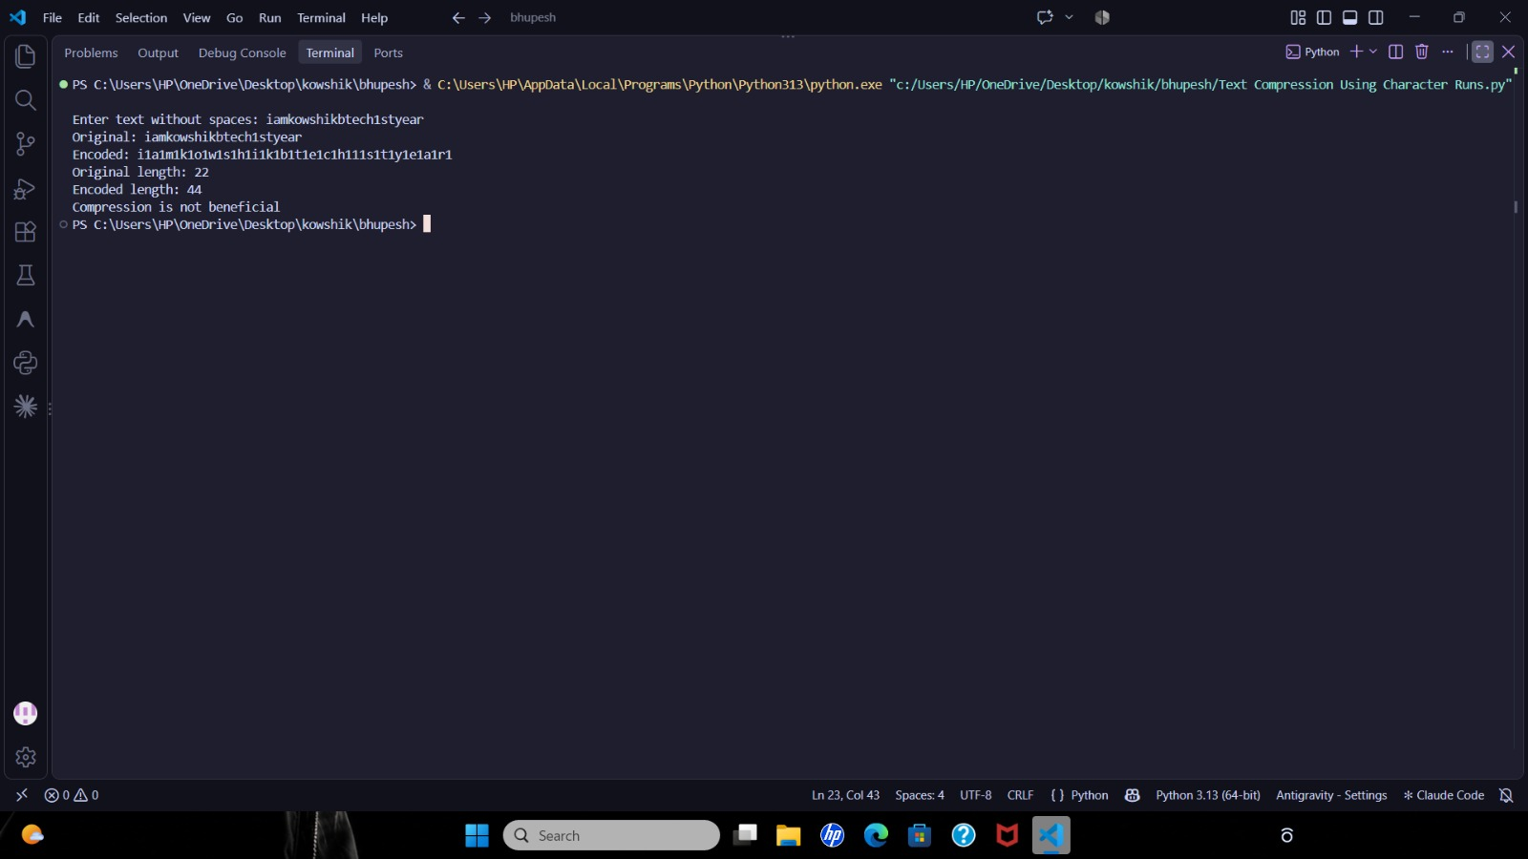

10. Conclusion

The Run-Length String Compression program was executed and verified successfully. The script demonstrates the implementation of sequential character inspection using string slicing (text[1:]), run-length aggregation, state tracking, and string length comparisons to assess data compression feasibility.

